HyperTrack: System Design Documentation
Use Case Diagram & Data Flow Diagram (Level 0 and Level 1)
Submitted for UCS503 — Thapar Institute of Engineering and Technology
Aditya Rajput, AIML | Prabhkirat Kaur, AIML — August 2026
1 Overview
This document presents the standard software-engineering design artifacts for HyperTrack: a Use Case Diagram showing how the user interacts with the system's major functions, and a Data Flow Diagram (DFD) showing how data moves through the system at both the context (Level 0) and detailed (Level 1) levels.
2 Use Case Diagram

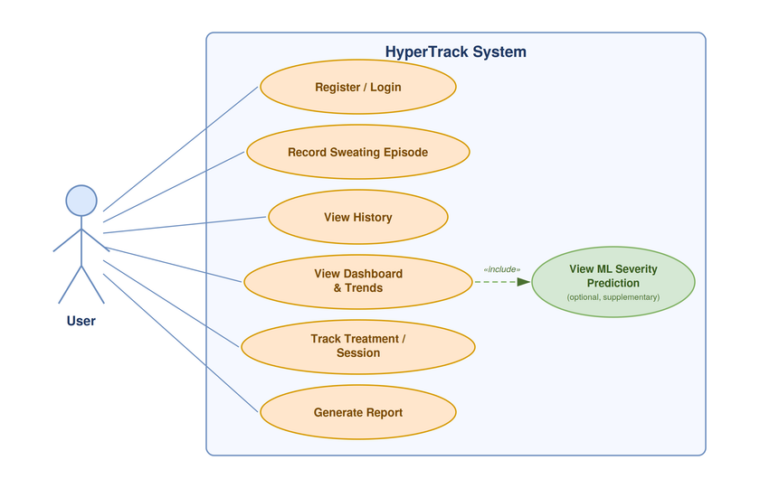

Figure 1: Use Case Diagram — User and the HyperTrack System
Use Case Descriptions
- Register / Login: The user creates an account or authenticates to access their records.
- Record Sweating Episode: The user logs an episode with severity, duration, affected body area, activity, stress level, and optional trigger notes.
- View History: The user browses previously recorded episodes.
- View Dashboard & Trends: The user views charts summarizing frequency, severity, and trigger patterns.
- Track Treatment / Session: The user logs treatments or sessions they are already following.
- Generate Report: The user exports a structured summary of their history, e.g. to share with a clinician.
- View ML Severity Prediction: An optional, supplementary use case included within the dashboard, showing a predicted severity category based on historical patterns. Never presented as a diagnosis.
3 Data Flow Diagram (DFD)
3.1 Level 0 — Context Diagram

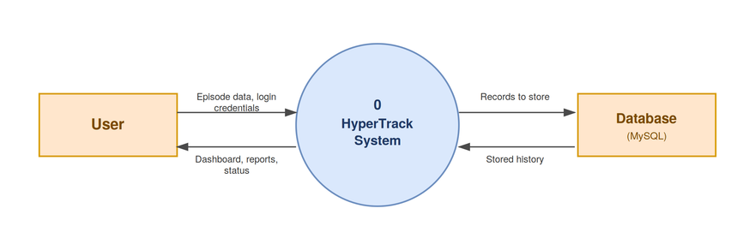

Figure 2: DFD Level 0 — Context Diagram
The context diagram shows HyperTrack as a single process exchanging data with two external elements: the User, who submits episodes and receives dashboards/reports, and the Database, which persists and returns records.
3.2 Level 1 — Detailed DFD

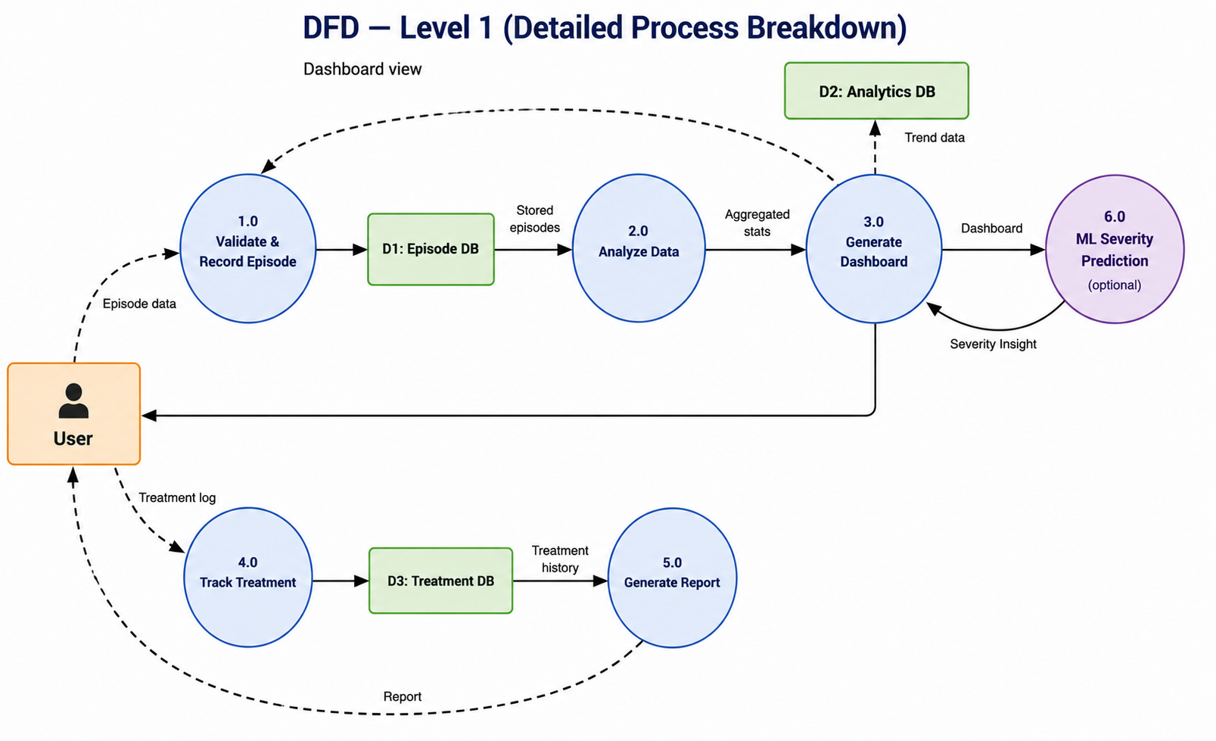

Figure 3: DFD Level 1 — Detailed Process Breakdown
Processes
- 1.0 Validate & Record Episode: validates and stores a new sweating episode.
- 2.0 Analyze Data: computes frequency, severity, and trigger statistics from stored history.
- 3.0 Generate Dashboard: renders the dashboard and pulls in the optional ML insight from 6.0.
- 4.0 Track Treatment: records treatment/session logs separately.
- 5.0 Generate Report: compiles a structured report from both episode and treatment history.
- 6.0 ML Severity Prediction (optional): supplies a supplementary severity insight to the dashboard, never presented as a diagnosis.
Data Stores
- D1: Episode DB — holds raw episode records.
- D2: Analytics DB — holds precomputed analytics/trend data.
- D3: Treatment DB — holds treatment/session records.

